Paper Tital : Potential use of cyanophyta species Oscillatoria limnetica in bioremediation of organophosphorus herbicide glyphosate

Author Names : Jjjjjj M. Ssssss ¹ * Eeeeeee Aaaaaaa¹

Affiliation 1Department of Biology, College of Science, University of Babylon,Iraq.
^{Email:-------}
^{ORCID ID:--------}
*Corresponding author: xxxxxxxxx@uobabylon.edu.iq
To cite this article:

Sssssss, J.M. and Aaaaa, E. Potential use of cyanophyta species Oscillatoria limnetica inbioremediation of organophosphorus herbicide glyphosate. Mesop. environ. j., 2015, Vol. x, No.x, pp. xx-x x .

This work is licensed under a Creative Commons Attribution-NonCommercial-NoDerivatives 4.0 International License.

Abstract:
(The abstract should be between 40 and 400 words,)

One locally microalga species Oscillatoria limnetica was isolated from the artificial canal around University of Babylon in Al-Hilla city. --------------------------------------------------------------------------------------------------------------------------------------------------------------------------------------------------------------------------------------------------------------------------
There ------------------------------------------------------------------------------------------------------------------------------------------------------------------------------------------------------------------------------------------------------------------------------------------

Keywords: ( 4-6 words ).

Introduction
As a result of human influence, --------------------------- in all aquatic environments [1]. Although the use of pesticidees ------------------ the contamination of water resources. This pollution can reduce water quality and lead to significant economic effects when pollutant --------------------------------------------------------- source [2 ; 3]. This contamination stems from the action of rainwater and irrigation water that can take these compounds and carry them to rivers and lakes that are used in cities for water supply [4].
Glyphosate---------------------------------------------- systems[4]. In the last decades glyphosate consumption has increased sharply and it has become one of the most used agrochemicals globally [5]. Glyphosate is a -------------------------------------------------------------------------------------- [6].
A treatment that promises to be efficient, economic and safe is bioremediation. This kind of treatment has been approached from a biotechnological point of view --------------------------------------- temperature and pressure and requires less energy than the conventional physical-chemical treatment technology, as well as avoiding additional damages to the environment [7]. Bioremediation may ------------------------ effectively [8].
Microalgae are eukaryotic, ---------------------------------------- microorganisms, as the blue-green algae (cyanophyceae) [9]. They are considered to be the principal agents for the degradation of pesticides in bioremediation processes. Their cell size, ------------------------------------------ pesticides. High surface area to biovolume ratio of algae provides greater potential for sorption and subsequent interaction with pesticides [10].
Therefore, this study wasconducted to investigate the survival and tolerance of cynophyceae species (Oscillatoria limnetica) with different concentrations of glyphosate, as well as evaluating their efficiency for removing and recovering this pesticide from contaminated water by high performance liquid chromatography (HPLC) analysis.
Material and Methods
Sample collection and identification
Samples of freshwater algae were collected from artificial canal around University of Babylon in Al-Hilla city by using phytoplankton net.
Phytoplankton net ----------------------------------- [11] was swept on surface water and samples were transferred into sterile plastic bottles/containers ----------------------------------- at once to be incubated in suitable and controlled conditions for algae growth [12]. Experimental cultures were --------------------- cycle of 16/8 h. and 26± 1°C [13]. Moreover the --------------------- on alternate days [14].
Preparation and sterilization of media

Modified BG-11 medium was used for the --------------- growth [15] quoted from [16]. The stocks were prepared for all macro and micro elements (Table1) and ----------------------. Micronutrient solution was sterilized by filtration through 0.22-mm polycarbonate membrane ---------------------- [17]. BG-11 medium was autoclaved at 121C° for 15min.when cooled, pH was adjusted to approximately ---------------------------- precipitation [18].

(font size=10 ) Table 1. BG-11 medium components

Components | Stock solution g.L⁻¹dH₂O | Quantity Used | Concentration in Final Medium (M)
NaNO₃ |  | 1.5 g | 1.76 X 10⁻²
K₂HPO₄ . 3H2O | 40 | 1 ml | 1.75 X 10⁻⁴
MgSO₄ · 7H₂O | 75 | 1 ml | 3.04 X 10⁻⁴
CaCl₂ · 2H₂O | 36 | 1 ml | 2.45 X 10⁻⁴
Na₂CO₃ | 20 | 1 ml | 1.89 X 10⁻⁴
Citric acid | 6 | 1 ml | 3.12 X 10⁻⁵
EDTA (disodium salt) | 1 | 1 ml | 2.79 X 10⁻⁶
Ferric ammonium citrate | 6 | 1 ml | ~3 X 10⁻⁵
Trace metals mix A5 | As shown below | 1 ml

Experimental Design

The selected algal isolates were batch-cultured in 500 ml Erlenmeyer flasks. Into each flask 200 ml of liquid culture media, BG11 medium for O.limnetica ,was added. Glyphosate was added to the culture medium to the final concentrations 5 , 10 , 15 , 20 mg/l. The flasks were cultivated under the conditions described above. After 3 , 5 , 7, 14and 35 days, 5 ml of algal cultures was filtrated by Millipore filter 0.45 µm. The algal filtrate was used to determine glyphosate residues in the culture medium by high performance liquid chromatography (HPLC).
Analysis of glyphosate removal
In agreement with the methodology described by [26]. The percent reductions of glyphosate were calculated by the equation:

Statistical Analysis

The general treatment -------------------------------- capacity of O. limnetica and Least significant difference (LSD) was used to compare the significant difference between means at p<0.05.

Results and Discussion

Data present in Table 2 illustrated that O. limnetica have the ability to biodegrade glyphosate at different concentrations and siginificant differences were recorded between initial and residual concentrations after 3, 5, 7, 14 and 35 days.

In agreement with these results [27]reported that mixed culture of Spirulina spp. showed a remarkable capacity to degrade the widely used organophosphorus herbicide glyphosate, that served as sole source of phosphorus for cyanophytal growth. Also, [28] study the tolerance of six cyanophytal strains to the herbicide up to millimolar concentrations. Four strains (Arthrospira fusiformis, Leptolyngbya boryana, Microcystis aeruginosa and Spirulina platensis) were able to use the phosphonate as the sole phosphorus (P) source for growth while two strains (Anabaena sp. and Nostoc punctiforme) EPSP synthase, which is in line with the findings of [29] who reported that tolerance of Anabaena variabilis ATCC 29413 is related to the presence of a ATCC 29413 is related to the presence of a resistant form of the target enzyme EPSP. [30] too stated that the existence of phosphorous-dependent glyphosate transformation with marine cyanophyta species Trichodesmium erythraeum.

Table 2. The residual concentration of glyphosate after (3,5,7,14,35) days and O.limnetica removal effenciency(%).

20mg/l |  | 15mg/l |  | 10mg/l |  | 5mg/l |  | Exposure  time (days)
Removal Efficiency  (%) | Residual  Concentration  mg/l | Removal Efficiency  (%) | Residual  Concentration  mg/l | Removal Efficiency  (%) | Residual  Concentration  mg/l | Removal Efficiency  (%) | Residual  Concentration  mg/l | Exposure  time (days)
------ | ------ | 16.22 | 12.56 | 28.25 | 7.17 | 60.89 | 1.95 | 3
------ | ------ | 24.64 | 11.30 | 32.13 | 6.78 | 97.33 | 0.13 | 5
50.68 | 9.86 | 30.98 | 10.35 | 33.90 | 6.66 | 97.55 | 0.12 | 7
76.82 | 4.63 | 37.1 | 9.4 | 57.9 | 4.20 | ------ | ------ | 14
99.9 | 0.02 | ------ | ------ | ------ | ------ | ------ | ------ | 35
 | 0.941* |  | 0.817* |  | 0.813* |  | 0.941* | LSD value
- (p < 0.05)
A significant differences between treatments and residual concentration after all days.

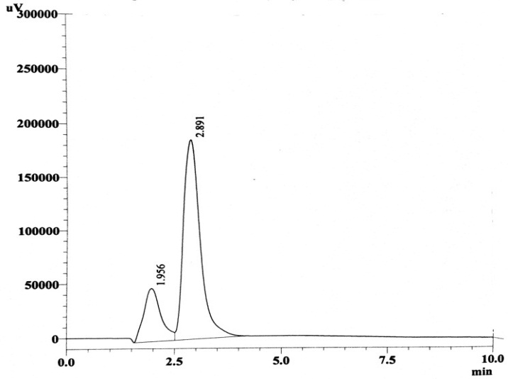
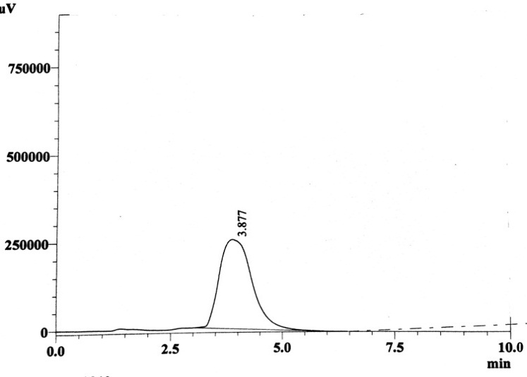
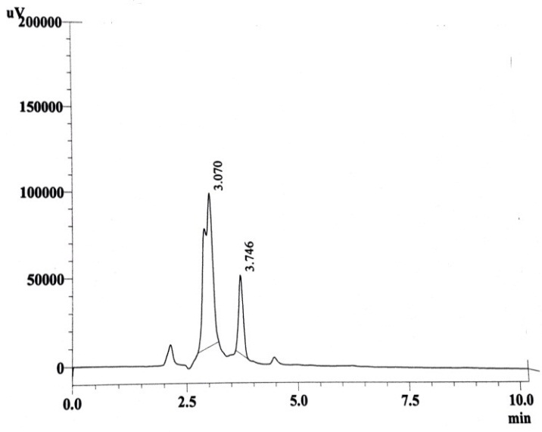
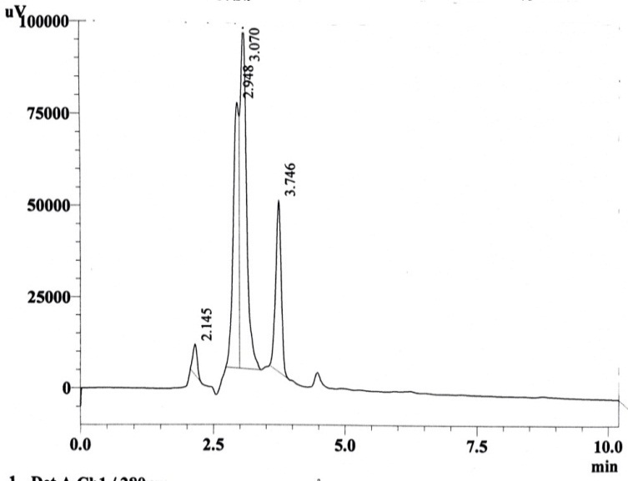
(A) (B)
(C) (D)

(font size =10) Fig. 1:Chromatogram of HPLC forGlyphosate standard solution at 5 mg/l (A) and sample of O.limnetica at 5 mg\l glyphosate concentration after 3 days (B), 5 days (C), 7 days (D).

Conclusions

(font size =10)
(1) The capacity of Oscillatoria limnetica to ------------------------------------------------------
(2) Glyphosate degradation was ----------------------------------------------------------------.
(3) Glyphosate removal --------------------------------------------------------------------------

Author Contribution

--------------------

Declaration of competing interest
--------------------------

Acknowledgment

(font size =10) The preferred spelling of the word “acknowledgment” in America is without an “e” after the “g”. Avoid the stilted expression, “One of us (R. B. G.) thanks . . .” Instead, try “R. B. G. thanks”. Put sponsor acknowledgments in the unnum-bered footnote on the first page.

References

(font size =10)
Article:

[-] Ali, U.;Syed, J. H.;Malik, R. N.; Katsoyiannis, A.; Li, J.; Zhang, G. and Jones, K.C.Organochlorine pesticides (OCPs) in South Asian region: a review. Science of the Total Environment, Vol.476/477,pp.705–717.2014.DOI:-------

[-] Fenner, K.; Canonica, S.; Wackett, L.P. and Elsner, M. Evaluating pesticide degradation in the environment: blind spots and emerging opportunities. Science, Vol.341,No.6147,pp.752–758.2013.DOI:-----

[-] Lipok, J.; Studnik, H. and Gruyaert, S.The toxicity of Roundups 360 SL formulation and its main constituents: Glyphosate and isopropylamine towards non-target water photoautotrophs. Ecotoxicology and Environmental Safety, Vol.73,No.1,pp.1681-1688.2010.DOI:------
Book:

[-]Andersen, R. A. and Kawachi, M. Traditional Microalgae Isolation Techniques In: Andersen, R.A. [Ed.] Algal Culturing Techniques. Academic Press, San Diego, pp.578.2005.

[-] Desikachary, T. V. Cyanophyta. Indian Council of Agricultural Research, New Delhi, pp.686.1959.

[-] Prescott, G.W. Algae of the Western Great Lakes Areas.Koenigstien, Germany, Ottokaeltz Science Puplishers, pp.237-488.1982.

[ -]APHA (American Puplic Health Association). Standard Methods for Examination of Water and Wastewater 2nd edition, Washington DC, U.S.A.2000

[-] Tredici, M.R. Mass production of microalgae: photobioreactors. In: Richmond A.[Eds.] Handbook of Microalgal Culture: Biotechnology and Applied Phycology. Oxford: Blackwell Science, 2004.

[-]Jacobs,I.S. and Bean,C.P. Fine particles, thin films and exchange anisotropy, in Magnetism, vol. III, G. T. Rado and H. Suhl, Eds. New York: Academic, pp. 271–350 ,1963.

Thesis:

[-] Jawad, A. L. M.Interactions Between Cyanobacteria and Other Microorganisms. Ph.D Thesis submitted to Liverpool University, pp.123-125.1982.

Conference proceding :
[-] Hassan,F.M; J. M. Salman, and Naji,A.S. “Water Qua- lity and Phytoplankton Composition in Al-Hilla River, Iraq,” Proceeding of 4th Conference of Environmental Science, University of Babylon, Babylon, 5-6 December 2012, pp. 144-160.
Report :
[-] Milne,T.A. Evans,R.J. and Abatzoglou, N. Biomass gasification “tars”: their nature, formation and conversion. NREL, Golden, CO. Report no. NREL/TP-570-25357, 1998.

